AMBU (Artificial manual breathing unit) to ventilator design strategies

In the wake of COVID-19 pandemic which is causing an unprecedented situation worldwide, it has become imminent to have medical equipment ready anticipating a huge pressure on our current medical system.

COVID-19 being an acute respiratory disease, caused by corona-19 virus, caused severe lung damage. Thus some severely affected patients might require artificial breathing units to support their life during the process of recovery. However ventilator facilities are limited to hospitals and are expensive. The alternate approach is to convert an AMBU to ventilator operated automatically without manual intervention.

Its back bone is a self-inflating bag which is squeezed by hand to push air into lungs of patients and the supporting valves takes care of the inhalation and exhalation processes. The first step is to make the squeezing process of the self-inflating bag a motorized process.

I am proposing some ways it may be achieved. Lots of refined will be necessary.

1. Squeezing the bag with fabric which is twisted around by a motor. 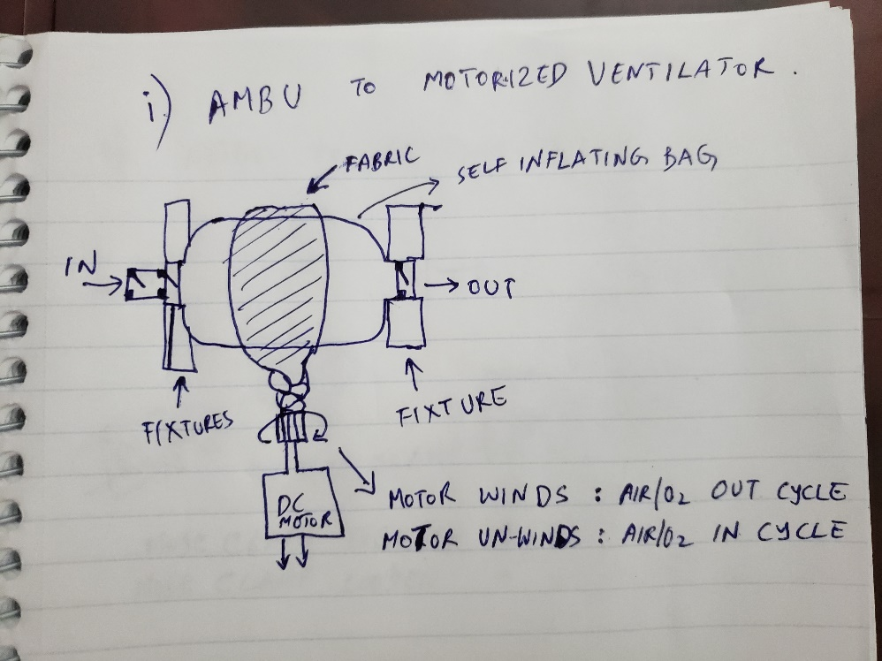

Might help more uniform compression.

Might require:

Large torque motors (even AC/DC might be sufficient).

Bag will get pulled towards the motor during the squeezing operation.

1. Squeezing the bag with hose clamp powered by a motor.

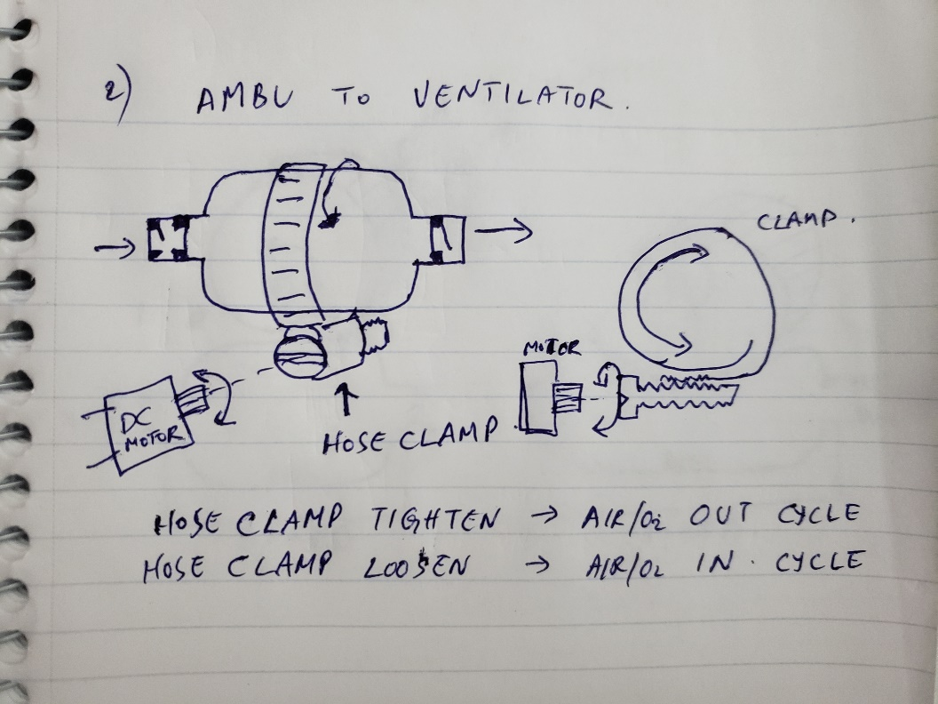

Faster rotation might be needed as the pitch of the clamp screw can be small. Here also there could be some lateral motion of the bag.

1. Eccentric CAM

